Docker Lab 02

Data Persistence, Custom Images, Networking & Docker Compose

Quick Day 1 Recap What We Learned Yesterday
Core Concepts:
Docker solves the “It Works on My Machine” problem Images = blueprints, Containers = running instances
Containers are lightweight and fast compared to VMs Images contain OS userspace but share host kernel Essential Commands:
do
c
ker

run

#
C
re
a
te

a
nd

st
a
rt

c
ont
a
iners
do
c
ker
ps
#
L
ist

c
ont
a
iners
do
c
ker

logs

#
V
iew

c
ont
a
iner

output
do
c
ker
exe
c
#
R
un

c
omm
a
nds

in

c
ont
a
iners
Quick Check:
#
V
erify

D
o
c
ker

is

running
do
c
ker
--
version
do
c
ker
ps
If you see any errors, make sure Docker Desktop is running!

Part 1: Data Persistence with Volumes
Why This Matters:
Before building complex applications, you need to understand how to keep your data safe.
Imagine building a blog and losing all posts when you restart!

The Problem: Container Data is Ephemeral
What Happens to Data in Containers?
Let’s see what happens to data when a container stops:
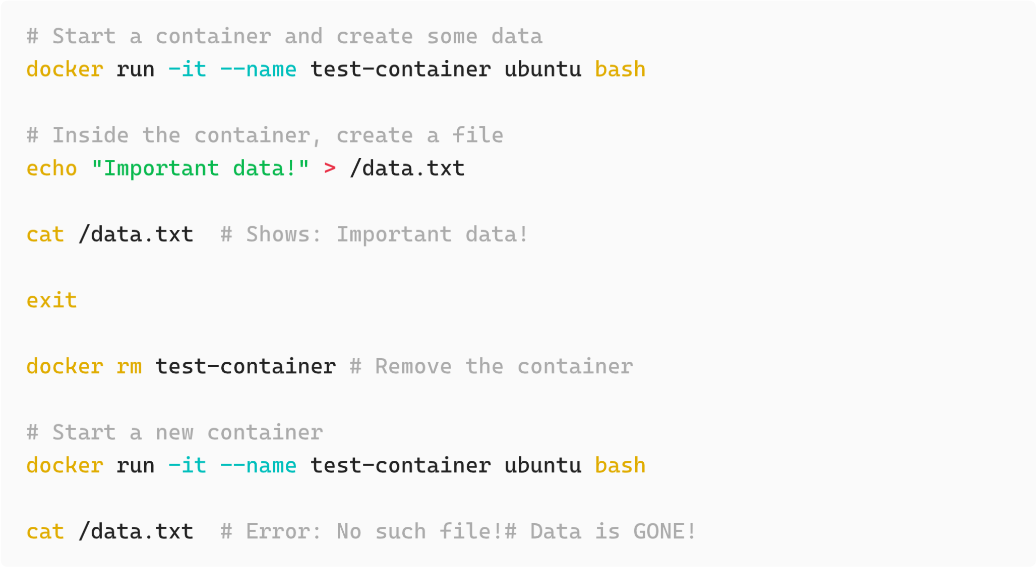
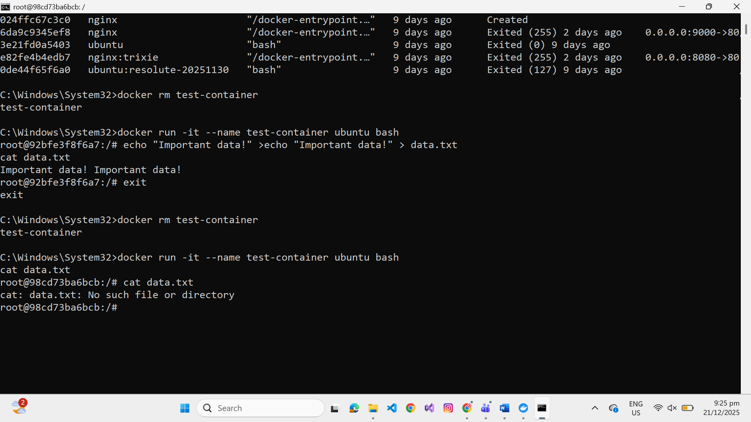
The problem:
Container filesystems are temporary
Data disappears when container is removed
Can’t share data between containers
Not suitable for databases, uploads, logs, etc.

The Solution: Docker Volumes
Volumes are Docker-managed storage that persists outside containers.
Think of volumes as:
External USB drives that you can plug into containers
Persistent storage that survives container deletion
Shareable between multiple containers

Types of Docker Storage

1. Named Volumes (Recommended for Production)
What: Docker-managed storage in a special location
Where: Docker manages the location (usually /var/lib/docker/volumes/ ) When: Databases, persistent app data, production use
#
C
re
a
te

a

n
a
med

volume
do
c
ker

volume

c
re
a
te

my
-
d
a
t
a
#
L
ist

volumes
do
c
ker

volume

ls
#
I
nspe
c
t

volume

det
a
ils
do
c
ker

volume

inspe
c
t

my
-
d
a
t
a
#
U
se

volume

in

c
ont
a
iner
do
c
ker

run

-
it
-
v

my
-
d
a
t
a
:
/
home
/
u
b
untu
/
my
-
proje
c
t

u
b
untu
#
R
emove

volume
(
only

when

not

in

use
)
do
c
ker

volume

rm

my
-
d
a
t
a
#
R
emove

a
ll

unused

volumes
do
c
ker

volume

prune
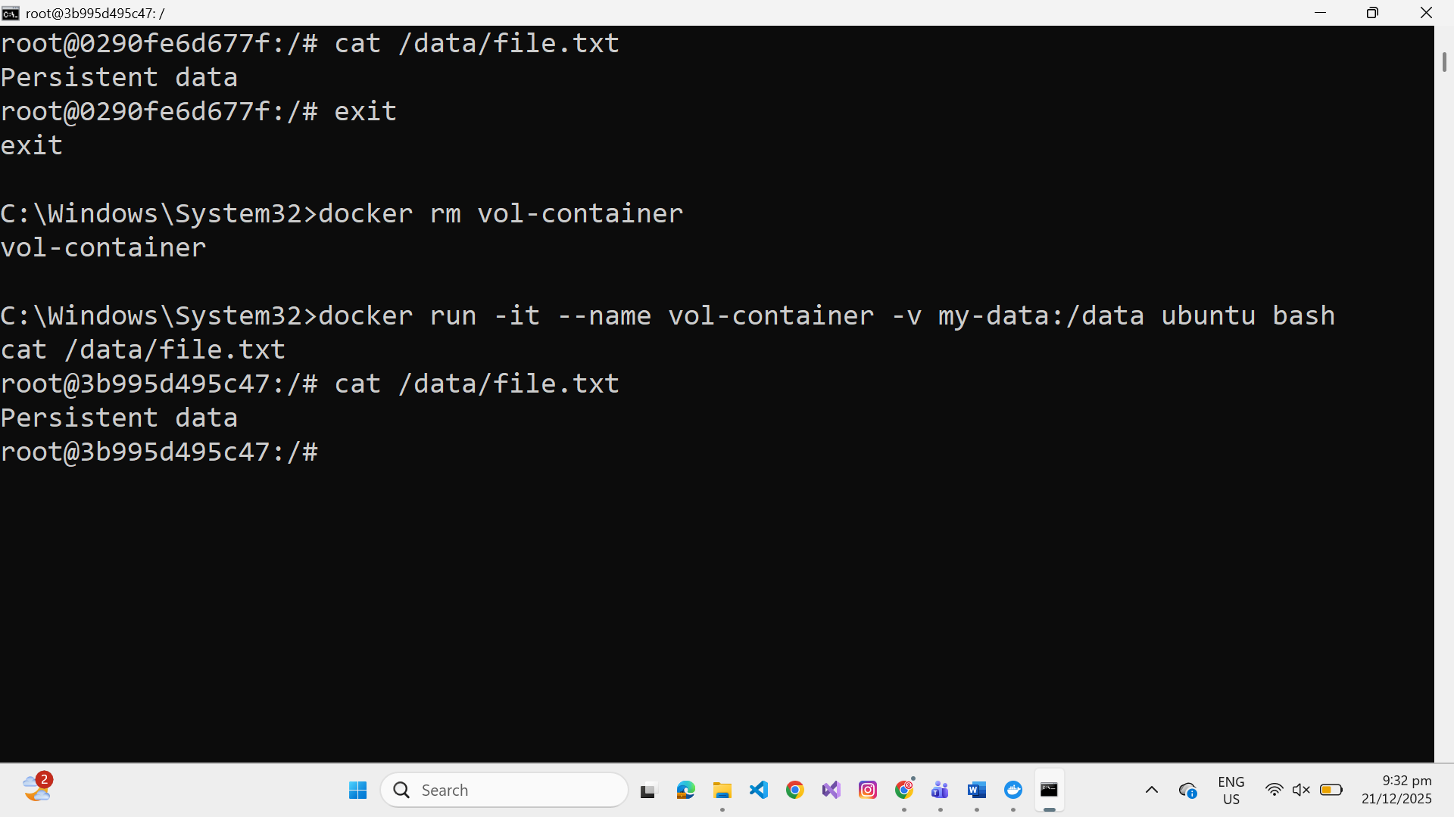

2. Bind Mounts (For Development)
What: Mount a host directory directly into container
Where: You specify exact host path
When: Development (live code changes), config files
#
M
ount

with

ab
solute

p
a
th
do
c
ker

run

-
it
-
v
/
home
/
user
/
my
a
pp
:
/
home
/
u
b
untu

u
b
untu

Volume Management Best Practices When to Use Which Type?
Storage Type | Use Case | Example
Named Volume | Production data, databases | PostgreSQL, MongoDB data
Bind Mount | Development, config files | Live code editing, nginx config

Part 2: Building Custom Images with Dockerfile
Why This Matters:
Now that you know how to use existing images, let’s create your own! This is where Docker becomes truly powerful - you can package your applications with all their dependencies.

Why Do We Need Custom Images?
So far, we’ve used pre-built images from Docker Hub:
do
c
ker

run

nginx
do
c
ker

run

node
:
18
do
c
ker

run

postgres
These are great, but they’re generic. What if you want to:
Add your own application code?
Install specific packages?
Configure custom settings?
Create a reproducible environment for your project?
Answer: Build your own images with Dockerfile!

Your First Dockerfile
Let’s create a simple custom image step by step!

Step 1: Create a Project Directory
c
d

~
mkdir

my
-
first
-
do
c
ker
-
a
pp
c
d

my
-
first
-
do
c
ker
-
a
pp

Step 2: Create a Simple Node.js Server
First of all Install
express
in your working working directory using
node
.
import

express

from

'
express
'
c
onst

a
pp

=

express
(
)
a
pp
.
get
(
'/'
,
(
request
,
response
)
=
>
{
response
.
send
(
'
H
ello

from

N
ode
'
)
}
)
a
pp
.
listen
(
3000
)

Step 3: Create Your First Dockerfile
Create file named
D
o
c
kerfile
. Name must be same.
#
U
se

N
ode
.
js

a
s

the

ba
se

im
a
ge
FROM

node
:
lts
-
a
lpine
3
.
23
#
S
et

working

dire
c
tory

inside

c
ont
a
iner
WORKDIR
/
a
pp
#
C
opy

our

a
ppli
ca
tion

file

into

the

c
ont
a
iner
COPY

index
.
js

.
#
C
opy

p
ac
k
a
ge
.
json
COPY

p
ac
k
a
ge
.
json

.
#
I
nst
a
ll

dependen
c
ies
npm
inst
a
ll
#
D
efine

the

c
omm
a
nd

to

run

when

c
ont
a
iner

st
a
rts
CMD

[
"
node
"
,
"
index
.
js
"
]

Understanding Each Instruction
FROM

node
:
lts
-
a
lpine
3
.
23
FROM:
The base image to start from
Every Dockerfile must start with FROM
a
lpine
variant is smallest (based on Alpine Linux)
WORKDIR
/
a
pp
WORKDIR:
Sets the working directory inside the container
Creates the directory if it doesn’t exist
All subsequent commands run from this directory
COPY

index
.
js
.
COPY:
Copies files from your computer into the image
index
.
js
= file on your computer
.
= current directory in container (
/
a
pp
)
CMD
[
"
node
"
,
"
a
pp
.
js
"
]
CMD:
The default command to run when container starts
Only one CMD per Dockerfile (last one wins)

Step 4: Build Your Image
do
c
ker

b
uild

-
t

my
-
first
-
a
pp

.
Understanding the command:
docker build = build an image
-t my-first-app = tag (name) the image
. = look for Dockerfile in current directory
What you’ll see:
Docker processes each instruction and creates layers. Watch the output!

Step 5: Run Your Custom Image
do
c
ker

run

my
-
first
-
a
pp
Congratulations! You’re now a Docker image builder!
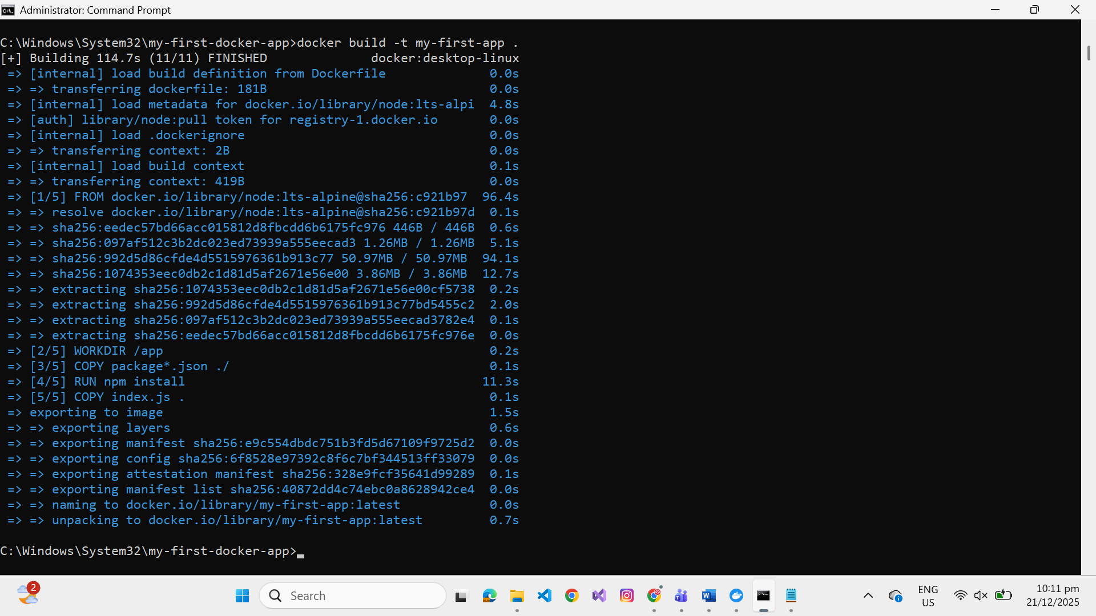
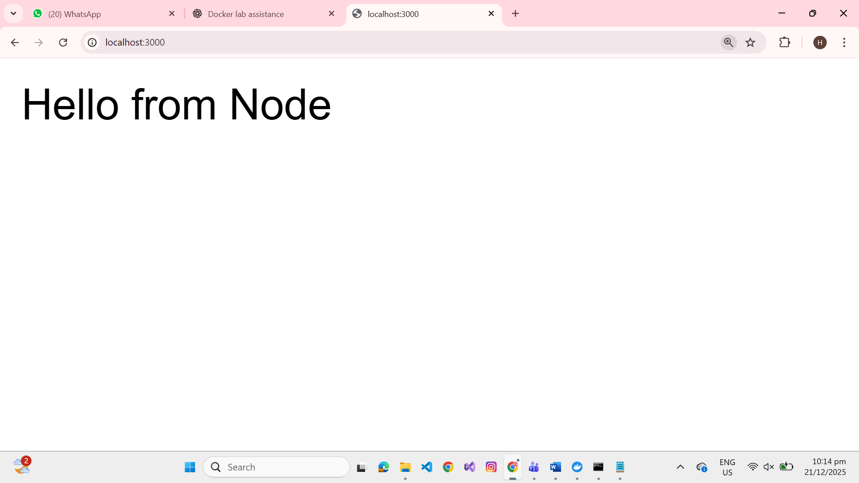

Essential Dockerfile Instructions
Let’s learn the most important Dockerfile instructions:

1. FROM - Choose Your Base Image
#
O
ffi
c
i
a
l

N
ode
.
js

im
a
ge
FROM

node
:
18
#
N
ode
.
js

with

A
lpine
(
sm
a
llest
)
FROM

node
:
18
-
a
lpine
#
O
ffi
c
i
a
l

P
ython

im
a
ge
FROM

python
:
3
.
9
#
Ub
untu
FROM

u
b
untu
:
22
.
04
Best Practice: Use official images when possible (verified, maintained)

2. WORKDIR - Set Working Directory
FROM

node
:
18
-
a
lpine
WORKDIR
/
a
pp
#
N
ow

a
ll

c
omm
a
nds

run

from
/
a
pp

3. COPY - Copy Files Into Image
#
C
opy

single

file
COPY

a
pp
.
js
/
a
pp
/
#
C
opy

entire

dire
c
tory
COPY
./
sr
c
/
a
pp
/
sr
c
#
C
opy

multiple

files
COPY

p
ac
k
a
ge
.
json

p
ac
k
a
ge
-
lo
c
k
.
json
/
a
pp
/

4. RUN - Execute Commands During Build
#
I
nst
a
ll

p
ac
k
a
ges
RUN

a
pk

a
dd
--
no
-
cac
he

c
url
#
I
nst
a
ll

N
ode
.
js

dependen
c
ies
RUN

npm

inst
a
ll

5. ENV - Environment Variables
#
S
et

environment

v
a
ri
ab
les
ENV

NODE
_
ENV
=
produ
c
tion
ENV

PORT
=
3000
ENV

APP
_
VERSION
=
1
.
0
.
0
#
A
v
a
il
ab
le

a
t

runtime

in

your

a
ppli
ca
tion

6. EXPOSE - Document Port Usage
Important:
EXPOSE is documentation only! Still need
-
p
flag when running.
#
D
o
c
ument

th
a
t

c
ont
a
iner

listens

on

port

80
EXPOSE

80
#
M
ultiple

ports
EXPOSE

80

443

7. CMD - Default Command
#
E
xe
c

form
(
re
c
ommended
)
CMD
[
"
node
"
,
"
a
pp
.
js
"
]
#
Ca
n

b
e

overridden

when

running

c
ont
a
iner
do
c
ker

run

my
-
a
pp

node

other
_
a
pp
.
js

Understanding Layer Caching
This is important for efficient Docker builds!
The Right Way:
#
✅

GOOD
:

D
ependen
c
ies

cac
hed

sep
a
r
a
tely
COPY

p
ac
k
a
ge
*.
json
./
RUN

npm

inst
a
ll
COPY

a
pp
.
js
.
The Wrong Way:
#
❌

BAD
:

E
verything

re
b
uilds

when

c
ode

c
h
a
nges
COPY
. .
RUN

npm

inst
a
ll
See caching in action:
Dependencies stay cached! Only
a
pp
.
js
is recopied. Much faster!
#
C
h
a
nge

a
pp
.
js
e
c
ho
"//
U
pd
a
ted
"
>>

a
pp
.
js
#
R
e
b
uild
-
w
a
t
c
h

for
"
CACHED
"
do
c
ker

b
uild

-
t

express
-
a
pp

.

Practice Exercise: Build Your Own Image
Challenge: Serve static HTML files from our previously build node server!

Part 3: Docker Networking
Why It Matters:
After learning how to build images, the next step is making containers talk to each other. Real applications often have multiple services like web servers, databases, and caches that need to communicate.

Why Containers Need Networks
Example scenario:
Frontend (React) talks to Backend (Express)
Backend talks to Database (PostgreSQL) and Cache (Redis) Problem: By default, containers are isolated and cannot see each other.
Solution: Docker Networks!

Containers Are Isolated by Default
do
c
ker

run

-
d
--
n
a
me

a
pp
1

a
lpine

sleep
3600
do
c
ker

run

-
d
--
n
a
me

a
pp
2

a
lpine

sleep
3600
do
c
ker
exe
c

a
pp
1

ping

a
pp
2
#
❌

Fa
ils
!

C
ont
a
iners

ca
nnot

c
ommuni
ca
te

b
y

def
a
ult

Custom Networks Solve This
#
S
t
a
rt

two

Ub
untu

c
ont
a
iners

on

a

c
ustom

network
do
c
ker

network

c
re
a
te

my
-
network
do
c
ker

run

-
d
--
n
a
me

a
pp
1

--
network

my
-
network

a
lpine

sleep
3600
do
c
ker

run

-
d
--
n
a
me

a
pp
2

--
network

my
-
network

a
lpine

sleep
3600
#
P
ing

from

one

to

the

other
do
c
ker
exe
c

a
pp
1

ping
-
c
2

a
pp
2
Cleanup:
do
c
ker
rm
-
f

a
pp
1

a
pp
2
do
c
ker

network

rm

my
-
network
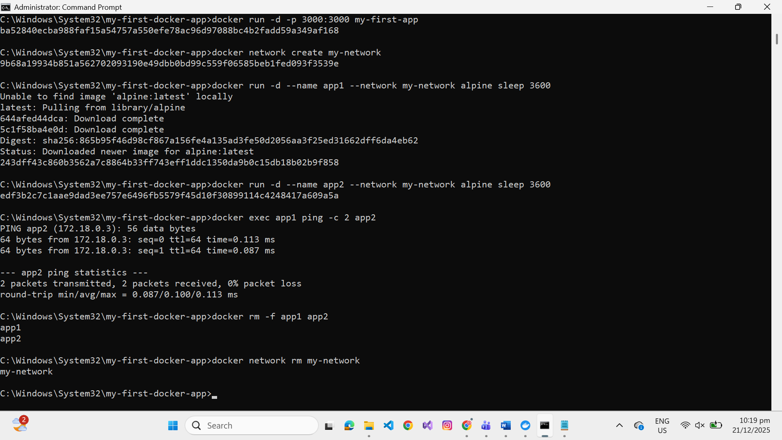

Types of Docker Networks
1. Bridge Network (Default)
Private internal network for containers
Use for most applications
2
.
Host Network (Advanced)
Container shares host’s network
Use for special cases needing maximum performance
Only works on Linux
do
c
ker

run

-
d
--
network
host

nginx

Key Takeaways
Containers on the same network can communicate
Container names work as hostnames (DNS)
No port mapping is needed for internal communication
Networks provide isolation: containers only talk if on the same network

Network Management Commands
#
L
ist

networks
do
c
ker

network

ls
#
C
re
a
te

network
do
c
ker

network

c
re
a
te

my
-
network
#
I
nspe
c
t

network
(
see

c
onne
c
ted

c
ont
a
iners
)
do
c
ker

network

inspe
c
t

my
-
network
#
C
onne
c
t

running

c
ont
a
iner

to

network
do
c
ker

network

c
onne
c
t

my
-
network

my
-
c
ont
a
iner
#
D
is
c
onne
c
t

c
ont
a
iner

from

network
do
c
ker

network

dis
c
onne
c
t

my
-
network

my
-
c
ont
a
iner
#
R
emove

network
do
c
ker

network

rm

my
-
network
#
R
emove

a
ll

unused

networks
do
c
ker

network

prune

Congratulations!
You’ve completed Day 2 and learned:
✅ Data Persistence - Using volumes to keep data safe
✅ Custom Images - Building your own images with Dockerfile
✅ Docker Networking - Connecting containers together
✅ Docker Compose - Orchestrating multi-container applications
✅ Best Practices - Writing efficient and secure Dockerfiles

Your Docker Journey
What you’ve accomplished in 2 Labs:
Lab 1: Running containers, managing images, basic operations Lab 2: Building images, connecting services, orchestration You now have the core skills to:
Containerize your own applications
Set up development environments quickly
Share reproducible environments with your team
Build multi-container applications

